**“All for One”**

**Group 9:**

Prudenciado

Alunan

Abellano

Piano

Alingalan

**CHRISTIAN LIVING EDUCATION**

**9C**

**Submitted to:** Ms. Liliveth Gustillo

**Introduction of the members of the Group:**

**Prudenciado -** My name is Eiji Prudenciado. I love doing things that make me feel comfortable. I’m an extrovert and I like interacting with people. I expect this PT to be a little bit complicated but fun.

**Alunan –** I’m Jillian Elexis Alunan. I consider myself as an introvert but sometimes an extrovert. I love to make friends and I have a really funny laugh. I think this PT would consume a lot of time but it’ll be bearable.

**Abellano –** My name is Eisha Ainzly Abellano. I’m the kind of person who appears shy at first, but after you get to know me, you’ll see the wacky side of me. I expect this quarter’s PT to be easy at first but I think it’s a little bit hard.

**Piano –** I’m Kian Piano and my hobbies are riding a bike and playing games. I think this PT will be hard but bearable with the help of my groupmates.

**Alingalan –** My name is Robe Allen Alingalan. I like to play some video games and do stuff that makes me comfortable. I think this PT will be confusing but it might be easy to understand as well.

**Introduction of the chosen Issue 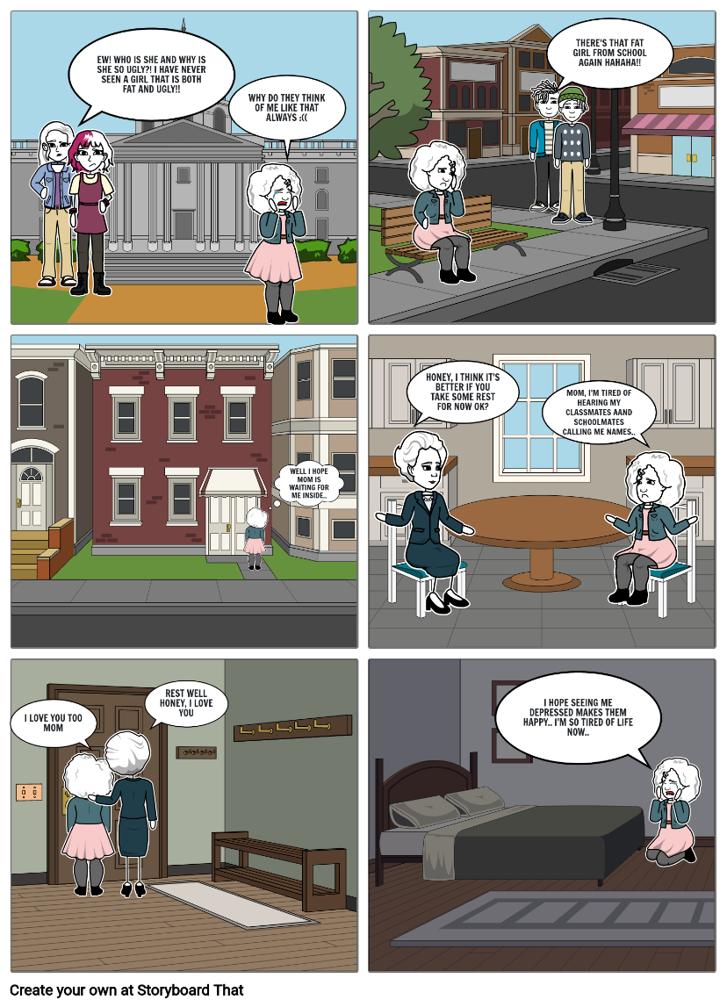(Depression):**

- Our comic strip shows how a person reacts when someone is bullying them. Depression is a serious matter and anyone who makes fun of a depressed person or is the reason of their depression is a really bad person. They should be charged and fined because of what they’re doing. Even in the church, everybody believes that those who are making fun of depressed people should be treated the way they treat a depressed person.

**Rationale:**

- Our project aims to make everyone feel not only accepted but also loved. We believe that everybody’s feelings should be valid. That is one of the main reasons why we started this project. We know how hard it is for people to come out and express their feelings in fear of being judged and discriminated against by random people, or worse, by people they know and love. Our project is welcome and open to everyone to help them feel validated. Which means they can tell us what they feel without the fear of being judged and discriminated against. We promise that everyone who will join and explore our project will feel important and significant in their own way. We hope that this project goes global and eventually helps the world be a better place. Encouraging them to accept their flaws is a really great thing to do because it will help them boost their confidence and be who they really want to be. Helping them gain back the happiness that they lost long before they joined this project of ours.

**Solutions to the chosen Issue (Depression):**

* **Interact**
* Be with people who really cares for you. Interact as much as possible to avoid negative thoughts.
* **Never skip meals**
* Yes, being depressed can be so hard, but starving yourself intentionally would do no good in fact, it’ll only make things worse than it already is
* **Don’t lock yourself up**
* Stop making yourself feel all alone at all times. Doing this increases your depression and will always make you think that no one will be there for you.
* **Hang out with loved ones**
* By doing this, I’m sure that you will feel less depressed and eventually gain more happiness because you get to do exciting things with your loved ones.
* **Love and accept yourself**
* Loving and accepting yourself for who or what you are is really nice and can help you cope up with depression. You’ll be more confident and feel less anxious when facing people.

**Objectives:**

* **Help them overcome depression.**
* Give them the love and affection they need. Make them as happy as possible. Depressed people needs to have attention because at that state, they can be suicidal.
* **Understand what they feel**
* Doing this will help us on treating them. Understanding what they feel is really important for us in order to help them bring back the happiness they lost.
* **Make them feel at comfortable**
* By being considerate about what they like most, they won’t have a hard time interacting with us and solving their problems. This could potentially make them happy and full of joy because they know that the people surrounding them are good people and not evil.

**Prayer and Acknowledgements:**

* **Prayer**
* Our almighty God, please forgive us for everything wrong we did in our lives. We humbly ask for your forgiveness in hopes of having mercy from you. We thank you for everything you have given us. We owe everything to you and look up to you. We hope that all of our PT’s for this quarter get a high score and great feedbacks. Amen.
* **Acknowledgements**
* We acknowledge the work of our leader and the contribution of our members for this PT and the efforts they exerted to accomplish this PT. We also acknowledge the work our teacher has done in order to give us this task. We’re not going to be able to complete this task if it weren’t for them.